BS1995_Haringey_TapeType_485C_PMS.eps

Health and Safety Procedure

HSP20 Lone Working Procedure

LONE WORKING SAFE SYSTEM OF WORK

**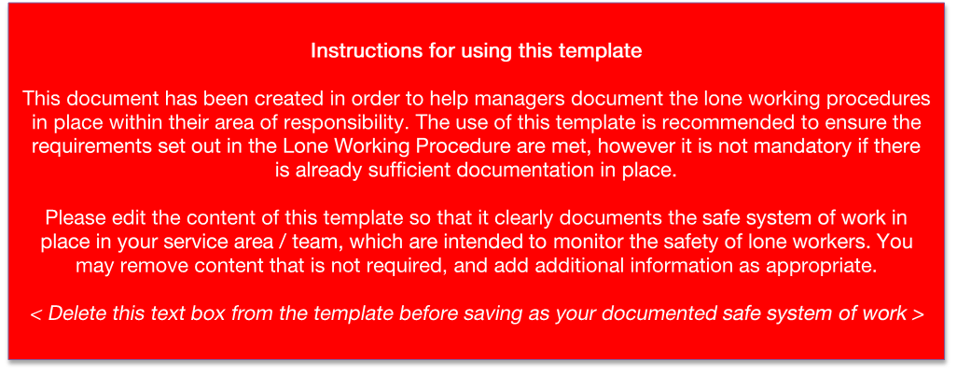**

This safe system of work applies to you if you work “without close or direct supervision” whether in your main place of work e.g. outside working hours, or because you work in the community.

Haringey Council has a Lone Working Procedure which should be read in conjunction with this Lone Working safe system of work.

**Team name:** <*insert team name*>

**Date:** *<insert document date>*

**Scheduled review date:** *<insert planned review date>*

1. **Planning your visits:**
   1. Before you attend a property in the community or any event, activity or meeting away from your normal place of work, the following information must be recorded so it is accessible.

* Organisation/contact name you’re going to see.
* Meeting location.
* A contact phone number.
* Employees to check *<insert database name>* to ensure no cautionary code/Person of Concern Code *(use applicable term)* is against the person / property being visited. If there is, discuss it with your line manager as lone working might not be appropriate.
* Indication of travelling time both to and from the event.
* Plan your journey and detail how you’re going to travel to the location and if possible the route you intend to take.
* Expected time to return to the office or to finish work.
* Before you leave your workplace or home for your meeting/event make sure your mobile phone is fully charged and make sure you take it with you.
* If your team uses lone worker devices, make sure its charged and you know how to use it.
* As well as recording the information about your visit, also schedule a ‘Check-In’ with your manager (or the person you’ve been instructed to check in with) for when you arrive at the location so they know you’ve arrived safely. Double check who you are ‘checking in’ with as this may change due to sickness or other meetings. **N.B.** This safe system of work will not apply if the employee has an automatic check-in system through a device or mobile phone.

Whenever Outlook is available to the employee, the information above will be recorded in their outlook calendars. All team members and managers will have a minimum of reviewer access to your outlook calendar but access to visit details should be restricted to your team. It is important that staff who need to include service user initials in the outlook calendar ensure that only their team has full view access to their outlook calendar and not wider council staff. Service users have a reasonable expectation that access to even this information will be limited as far as possible. The default calendar setting should be free/busy/time and this should be used when sharing outlook calendars beyond the team.

All staff must ensure that their outlook calendars are up to date at all times. <*insert method if outlook calendar is not available e.g. team board.*>

This team method to check in would be <*insert method e.g. outlook calendar/text message/phone call, etc. The preferred method would be Outlook calendar as explained in point 2.*>

* 1. Travelling to the location:
* Do not show off your valuables (either in your hand or car), this may draw the attention of a thief or mugger.
* Mobile phone use should be avoided whenever possible in public places. If someone does try to steal the phone it should be handed over immediately.
* Check you have extra money for emergency travel fare or petrol.
* If you are driving:
  + Make sure you have enough petrol.
  + Keep your car doors locked as you’re driving.
  + Have your keys ready as you approach your vehicle.
  + Check the interior of your vehicle before getting in and lock the doors as soon as you get in.
* Ensure that you park in a well-lit, preferably public place – park as close to the location you’re visiting as you can and reverse parking if possible.
* Notice the local area before you park up – e.g. where is the nearest shop? Is there a police station nearby?
* Try and sit near to the driver on public transport whenever possible.
* Avoid putting yourself in a potentially dangerous position - do not take poorly lit shortcuts, use main roads where possible, don’t drive or speak aggressively.
* If your plans change, let your manager/the person you check in know.
* Wear comfortable shoes and clothing you can easily move in.
* Make sure you are in a safe location before checking in or using your mobile phone.
* Lone workers should walk briskly and if in need of directions should utilise public places such as a petrol station.
  1. During the works/visit:
* Assess the situation on approach and be prepared to abandon or postpone the visit if there is a concern for safety.
* Wear your ID when you reach your destination.
* Inform the person you are going to visit about the reason for the visit and the approximate time it will take.
* If the person answering the door makes you feel uneasy about entering, then an excuse should be made not to enter.
* You should follow the occupants in when entering and not take the lead.
* Remain alert while in the house/premises, look for anything that may present a problem.
* When taking a seat within the property, try to seat near an exit route.
* Be aware of any obstacles that may prevent you exiting the premises quickly.
* Pets (especially dogs) should be put away before you enter the premises.
* Clients/tenants should not smoke in the room you are working/carrying out the meeting.
* If you are delivering bad news, do not carry out the meeting in a room where items could be used as a weapon e.g. kitchen.

If you see anything to cause you concern

Trust your instincts. If you feel threatened or the risk has increased to an unacceptable level, abandon the area and contact your line manager (or designated person) from a safe place.

* 1. After the works/visit:
* Remove your ID or keep it beneath your outer wear when you leave the premises.
* Do not make unscheduled visits.
* Call the office or a colleague if you need further directions.
* Avoid lingering longer than required in the area, particularly during dark hours.
* Inform your line manager if you go home directly.

1. **How to Create a Check-in (Outlook users)**

Enter all of the details listed in part 1.1 into your Outlook diary and invite your manager (or the person you’ve been instructed to check in with) to a meeting using the Outlook meeting request function so that the information shows in their calendar too and sends them a reminder message.

The check-in (meeting) time should be at the time you expect to arrive at the location and leave the location.

* 1. How to Check-in:

A text message is acceptable in the following circumstances:

* Arrival at or leaving after a formal event/meeting such as a conference.
* Returning home after an event/meeting when you’ve been with a colleague e.g. summer fair.
* Returning home after an event/meeting in a public place.
* Returning home after a meeting at a home or small office. You must call your manager in these instances
* When you arrive and leave at a person’s home.
  1. What happens if a check-in isn’t received?

Your Manager (or designated person) will text you 10 minutes after your check-in time.

If you do not reply to that text, they will ring you 20 minutes after your check in time. If you know you’ll be later checking in, contact them as you leave the location to give them a revised ETA – if you’re driving, do not use your mobile phone. Pull over somewhere safe before texting or calling. Also inform the person you will be visiting of the ETA.

If no check-in has been received after 30 minutes, your manager (designated person) will check traffic/public transport reports for delays on your journey route, which may explain why you have not checked-in.

If no contact is made after an hour of the check-in time, the manager (designated person) will call your relevant landline phone number to see if you have returned home. If there is no reply, the manager will seek guidance from Head of Service.

The Head of Service may then decide to contact your next of kin.

1. **Code ‘Red Folder’: Raising the alarm**

If an employee/colleague uses the phrase “Please check the red folder” this indicates that an individual feels uncomfortable or unsafe but is unable to say so.

This phrase is not to be used in any other context, other than that stated below:

* If a staff member is in a situation where they feel uncomfortable:
* The staff member should leave immediately wherever it is possible to do so without inflaming the situation.
* If the staff member cannot leave the situation they should ring the office using the coded phrase ‘Please check the red folder’.
* If the staff member rings and the person who receives the call is in any way concerned by the call, but this phrase is not being used, they should ask, ‘Do you want me to check the red folder?’
* If the staff member uses the coded phrase or answers yes to the question, try to confirm the staff member’s whereabouts and then the manager should be informed immediately. If there is no manager available within the team, inform the nearest manager in any team.
* The manager will then call the police.
* If the staff member later manages to leave the property they should ring back as soon as possible and inform everyone that they are safe.

If a staff member is in a situation where they feel uncomfortable and has a silent alarm system:

* The staff member should use the lone working device as trained.

The staff member should leave immediately wherever it is possible to do so without inflaming the situation.

If the Police are called:

* The manager will inform senior management of the concerns.
* The manager will again contact the emergency contact and explain that they have informed the police.
* The manager and senior manager will agree how best to continue to liaise with the police and emergency contact.

1. **Lone working in a building/working elsewhere e.g. home**

* Familiarise yourself with the location of the emergency exits and how to raise the alarm (if available).
* Ensure you have means of communication e.g. landline phone, mobile phone, radio, etc.
* Ensure you have checked in with your manager (or the person you’ve been instructed to check in with).
* Know where the first aid kit is located (expect public place) and how to call for help if necessary.
* If you think the building has been broken into, do not go inside. Wait for back up.

You will check-in with your manager <*insert agreed times*.>